Addendum to Product Assessment Report

Care Plus Anti-Insect DEET Spray 20%
Kruidvat anti-insect spray 20% DEET
Trekpleister anti-insect spray 20% DEET
NL-0008565-0000

1 June 2018

Addendum to biocidal product assessment report related to product authorisation under Regulation (EU) 528/2012

Contents
Contents 0
Background 1
2.1 Assessment of new data 1
2.2 Conclusion 3

Background
An application for a major change was received concerning the use of Care Plus Anti-Insect DEET Spray 20% / Kruidvat anti-insect spray 20% DEET / Trekpleister anti-insect spray 20% DEET (R4BP case number: BC-EB031705-63).

The following changes were applied for:

- Changing the number of dosings from 1 to 2 dosings per day for adults and children ≥13 years of age.
- Allowing the use of a maximum of 1 dosing per day for children younger than 12 years of age.

Assessment of new data
Human health
For the original risk assessment, exposure to the product was evaluated. For the calculations, a user survey study has been performed in the USA involving human use and exposure to insect repellents containing DEET (Boomsma and Parthasarathy, 1990 (III-A6.14)) was used, based on the 75th percentile and taking into account the age groups and body weights as included in the study. For the original authorisation, 1 dosing per day was evaluated. Furthermore, for dermal absorption a value of 20% was taken into account. The resulting outcome for dermal absorption is included below in Table 1.

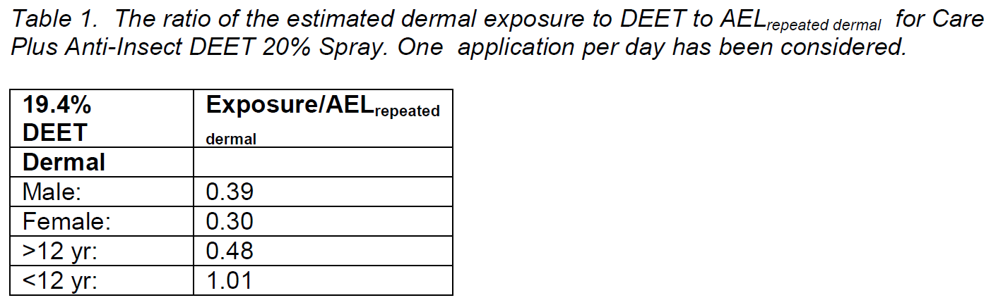
The applicant submitted an application to change this number of dosings from 1 to 2 times a day. Considering the risk indices as shown in the table above and taking into account that
the contribution of oral exposure for children > 2 years old and adults is considered negligible, we can agree with the applicant that for adults and children > 12 years of age no adverse health effects are expected by using the product 2 times a day.

Furthermore, the applicant submitted an application to allow a maximum of 1 dosing per day for children younger than 12 years of age. In the original risk assessment, as the risk index was above 1, the application for children below 12 years of age was not allowed. The applicant argues that the used dermal absorption of 20% is conservative, as this value was based on a human dermal absorption study under semi-occlusion and the effect of the vapour pressure of DEET was not taken into account.
The following information is included in the CAR of DEET; “DEET is absorbed slowly, metabolized completely, and excreted rapidly when applied to human skin. Less than 9% (20% when corrected for total recovery) of a dermally applied dose of DEET, either as a 15% (w/w) solution in ethanol or as the undiluted technical grade material, is absorbed through the skin during an 8-hour exposure period as demonstrated by urine samples collected over 5 days following application.”

Based on the calculations, a risk index of 1.01 is derived. The tested material in the human volunteer study is considered comparable, slightly worst case for the product applied for. Furthermore, we agree with the corrections for recovery, as the urine samples show that DEET is excreted in the urine. However, we agree that as the tested formulation is applied for 8 hours under semi-occlusion, the slight exceedance of 0.01 of the risk index for dermal exposure could be considered acceptable for children below 12 years of age.
It is noted that only dermal exposure is taken into account. In accordance to the CAR of DEET, oral exposure for children > 2 years old and adults is considered negligible. For children younger than 2 years of age, oral exposure is expected, and therefore based on the considered information adverse health effects due to exposure to DEET by using the product cannot be excluded, and therefore cannot be authorised. Furthermore, this is line with the Inclusion Directive (2010/51/EU) of DEET.

Additionally, a lot of discussion has taken place how to communicate the ages in the instruction of use (as the study only includes indication of < and > 12 years of age). This is taken into account in the conclusion below.

In conclusion, Care Plus Anti-Insect DEET Spray 20%/ Kruidvat anti-insect spray 20% DEET/ Trekpleister anti-insect spray 20% DEET
- can be used twice a day by adults and children ≥ 13 years of age;
- can be used once a day by children < 13 years of age;
- cannot be used for children < 2 years of age.

Environment
The highest 90 percentile PEC/PNEC (0.95) was calculated for a single application of the product and direct emission to the aquatic environment from a high density of swimmers in a swimming area (Dutch swimming scenario). Six out of 72 lakes showed a PEC/PNEC > 1 for a high density of swimmers in the swimming area. Two applications instead of a single application of the product per day will result in a 90 percentile PEC/PNEC > 1 and more than six out of 72 lakes with a high density of swimmers in the swimming area with a PEC/PNEC >1.
However, presence of a high density number of swimmers in a swimming area is considered to be occasional and the release of DEET into the swimming area can be considered intermittent. Furthermore, the DT50 of DEET is 15 days at 12°C but degradation will be even more rapid at higher water temperatures, not unusual in shallow swimming areas warmed by the sun during the swimming season. During release the PEC/PNEC ratio’s are thus expected to be above 1 just for a short period of time and therefore the risk to aquatic and sediment organisms is considered acceptable also for two applications of the product per day.

Conclusion
The change of the product applied for is not expected to affect the conclusion with regard to the fulfilment of the conditions of Article 19 BPR.
Based on the human health risk assessment of the application of change, Care Plus Anti-Insect DEET Spray 20% / Kruidvat anti-insect spray 20% DEET / Trekpleister anti-insect spray 20% DEET :
1. Can be used twice a day by adults and children ≥ 13 years of age.
2. Can be used once a day by children < 13 years of age.
3. Cannot be used for children < 2 years of age.

